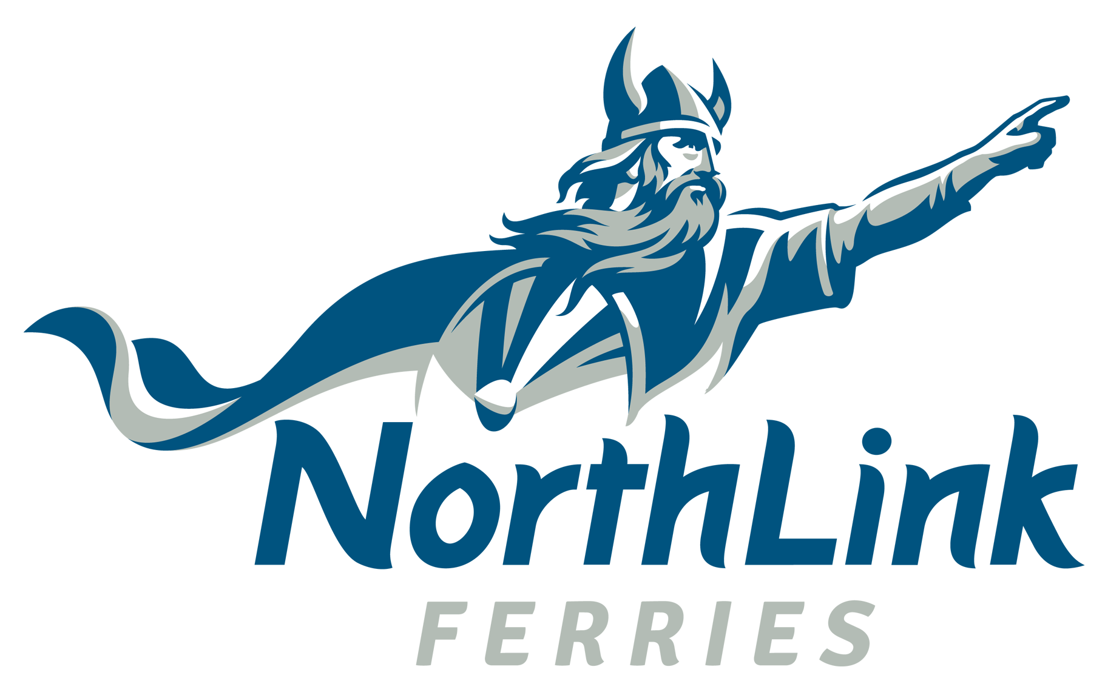
Group Booking Form

Completed forms should be emailed to groups@northlinkferries.co.uk

Contact Details
Group Name:
Booking Contact Name:
Address details: |  |  |  | Postcode
Daytime Phone Number: |  |  | Mobile Number:
Contact Email:

Please include the following, if applicable to your group:
NorthLink Account Number |  | Sponsorship Code

Booking Requirements: Outward Journey
Journey Details |  | Passengers Numbers |  | Accommodation Required
Date |  | Adults  (16+) |  | Total Standard  2 berth
Route |  | Student  (16+) |  | Total Standard  4 berth
Time |  | Children  (5-15) |  | Total Pods
Vehicle Details
Any additional Information, including any cabin upgrades:

Return Journey
Journey |  | Passengers Numbers |  | Accommodation Required
Date |  | Adults  (16+) |  | Total Standard  2 berth
Route |  | Student  (16+) |  | Total Standard  4 berth
Time |  | Children  (5-15) |  | Total Pods
Vehicle Details
Any additional Information:

If your group has any additional journey legs, please copy and paste the tables above, and complete for these additional legs.

Please return your completed form to groups@northlinkferries.co.uk

A name list and cabin allocation form will be required to be completed prior to travel. This will be sent to you along with your booking confirmation.

